# Importing ShipTos via Excel Data

A-F-1 (Customer File) has a “Import” button available on the “Ship To” tab for a customer. This function allows a user to import data in a structured Excel format as a replacement for entering ship-to manually.

Here is an outline of the user-interface:

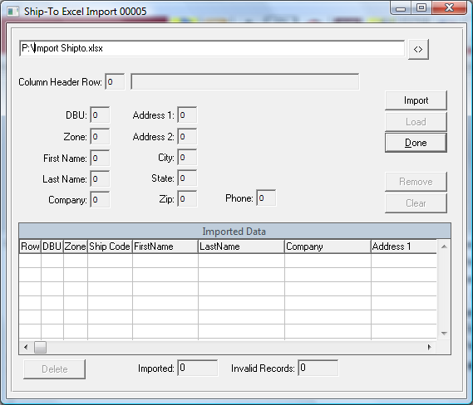

1. Click the import button
2. Enter or select a .xls or .csv file that contains the data

After you hit “Import”, a screen should display the # of records imported successfully.

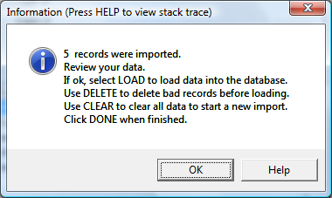

The interface will display the data that was imported, as well as the column numbers that it used for each data field. You can review the data and delete any erroneous records.

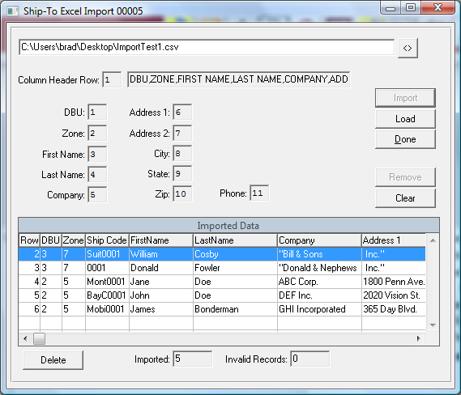

1. Once you’ve reviewed the data, you can “Load” the data into the system.
2. Review the data and “Delete” any erroneous records. You can also “Clear” to start over.

The Excel Data must be in the following format:

1. There must be a header line for the data that includes the following columns:
   1. DBU
   2. ZONE
   3. FIRST NAME
   4. LAST NAME
   5. COMPANY
   6. ADDRESS 1
   7. ADDRESS 2
   8. CITY
   9. STATE
   10. ZIP
   11. PHONE (########## format)
2. The columns can be in any order and don’t have to contain data. For best results, having only these columns in the input file is recommended.
3. There should be no commas in any of the data fields. This will break the .csv that gets automatically generated from the .xls file
4. Sample .xls file:

